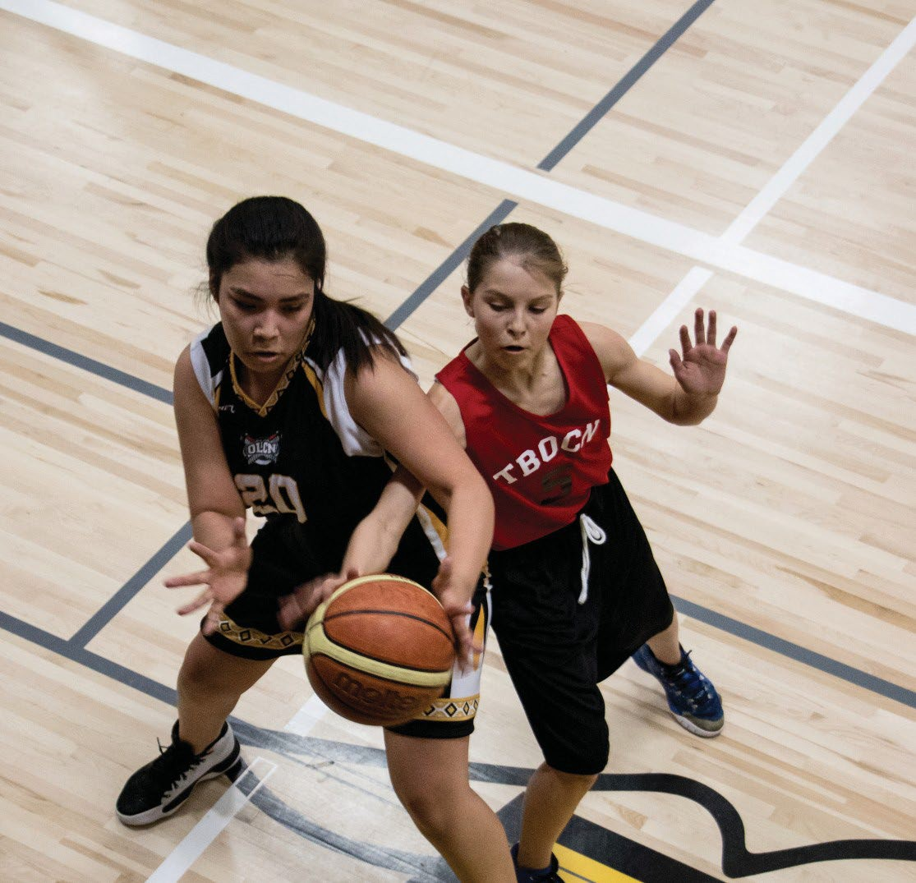


INDIGENOUS COMMUNITY SPORT DEVELOPMENT
GRANT PROGRAM
GUIDELINES 2026

INDIGENOUS COMMUNITY SPORT DEVELOPMENT GRANT PROGRAM GUIDELINES

Purpose
The purpose of the Indigenous Community Sport Development Grant Program is to provide greater sport participation and development opportunities for Indigenous youth in Saskatchewan. The program will assist and support the implementation of organized community sport programs to increase sport opportunities for youth in the Indigenous community, specifically in urban, rural, on-reserve, isolated and northern communities.

The Indigenous Community Sport Development Grant Program will focus on communities and building their capacity to offer quality, organized sport programs** for Indigenous youth.
The goals of the initiative are:
- Increase the number of Indigenous youth participating in organized sport programs in Saskatchewan.
- Increase the numbers of volunteers available to organize and assist with sport teams and clubs.
- Encourage communities to work cooperatively with others communities or sport groups to organize leagues, tournaments and competitions.
- Provide resources to assist communities with introducing new, organized sport programs** that include coaching or leadership components.

** Organized sport programs include a full spectrum of community support including facility access, volunteers, coaching, leadership, children and youth. Additionally, a full- range of sport participation opportunities must be considered and provided, starting with exposure to different sports; then introducing sport skills instruction; then onto organizing teams, clubs, leagues and tournaments; and then offering opportunities for higher levels competition, often outside of the community. For all this, coaching and volunteer leadership from within the community are key!

The Indigenous Community Sport Development Grant Program is jointly funded through Sport Canada’s Aboriginal Participation Bilateral through the Province of Saskatchewan and the Sask Lotteries Trust Fund for Sport, Culture and Recreation.


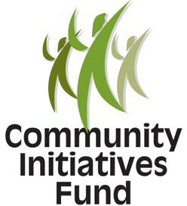
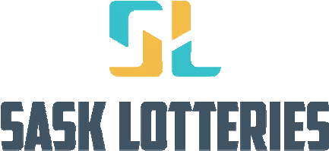

What is the Sport Canada Indigenous Participation Bilateral?
Through a shared, bilateral agreement with Sport Canada a federal contribution is provided to support the capacity of provinces and territories to work with the Indigenous community and mainstream sport towards achieving the goal of increasing the sport participation levels of Indigenous Peoples’.

What is the Sask Lotteries Trust Fund for Sport, Culture and Recreation?
The Sask Lotteries Trust Fund for Sport, Culture and Recreation was created in 1974. The Trust Fund receives its revenue through the sale of Sask Lotteries products throughout the province. Sask Sport manages and administers Sask Lotteries through a license agreement with the Government of Saskatchewan. The Sask Lotteries Trust Fund funds sport, culture and recreation initiatives in over 800 communities and to more than 12,000 volunteer groups through the global organizations of Sask Sport, SaskCulture and the Saskatchewan Parks and Recreation Association.

Who are Sport, Culture and Recreation Districts?
The Sport, Culture and Recreation Districts are volunteer driven organizations that have a mandate to facilitate community development through sport, culture and recreation for people and communities throughout Saskatchewan.

Who is Eligible to apply?
- Organizations that provide services with First Nations and Métis people and are registered under the Saskatchewan Non-Profit Corporations Act are eligible to apply (these organizations must have been incorporated and in existence for a minimum of one year) or
- Communities are eligible to apply provided endorsement is received from a Bonded Authorized Officer (Ex. Mayor, Reeve or Chief).
- Applicants must have appropriate levels of participants insurance covering projects, events and activities that fall under its sanction.
- Ineligible communities or organizations may partner with eligible communities/organizations to apply for support and deliver activities that meet the objectives of the program.
- Individuals may not apply for funding assistance through this program. All projects must be supported by a community or eligible organization.
- Recipients unable to comply with grant guidelines (Ex. late or incomplete application or follow-up reports) will not be considered eligible for future funding for a 3-year grant year period. A follow-up will be required to release the current grant year funds. For new applications following the 3-year period, funds will not be released until a follow up for the current grant is provided.

How much Grant funding is available?
- Recipients are permitted to apply for more than one community sport initiative; however, a separate application per initiative is required. If an organization or community is submitting more than one application, consideration will be given to the second or subsequent application(s) after all other community submissions have been reviewed.
- The maximum eligible amount a community can receive per initiative is $5,000 per year. The minimum application amount to be considered is $1,000 per initiative, per year.
- Organizations with a provincial reach or mandate may apply for funding on behalf of communities when working in multiple communities. The maximum amount an organization can receive is $5,000 per community with a total maximum of $25,000. Only one grant application is required when applying for multiple communities rather than each community needing to fill out an individual grant application. Each participating community must provide a letter of support for the program.

Grant Application Requirements
- Applications must include an application and budget.
- The application must demonstrate how the community intends to continue and sustain the sport program(s) after the grant funding period has ended. This may include plans to seek out and obtain additional funds or other resources that will build and enhance sport programs.
- Provide one letter of support from community leaders (Ex. school administrator, town administrator, minor sport organization president, recreation board chair or community elected official).
- Sport Canada and Sask Lotteries Trust Fund for Sport, Culture and Recreation must be publicly acknowledged in all communications, correspondence and promotions as the source of funds for the program.

What is the application process?
- Eligible communities or organizations must engage members of the community and work in collaboration to complete the application.
- Communities or organizations may submit complete print form application to their district office or to Sask Sport.
- Communities or organizations can also submit an application online by visiting www.sasksport.ca
- Communities or organizations will be eligible to apply for funding by the following application deadline(s):

The deadline for applications is April 30 and October 31 annually.

- Communities or organizations should send completed print form application forms to:

Indigenous Community Sport Development Grant Program

Rivers West District for Sport, Culture & Recreation Inc.
Box 607 Kerrobert, SK S0L 1R0
ATTN: Bobbi Hebron, Community Development Coordinator
PH: 306-494-7771 EMAIL: cdcrosetown@riverswestdistrict.ca

Eligibility Criteria
- All activities and eligible expenditures must be expended within the fiscal year the grant is received.
- Retroactive funding for past or existing projects and activities is not eligible.
- Extensions beyond the end of the grant period will not be allowed.
- Programs must meet one or more of the following objectives:
  - Aim to increase the number of long-term organized sport programs involving First Nations and Métis children and youth.
  - Provide opportunities for ‘new’ organized sport programs in the community or provide extended, sport participation opportunities within existing community sport programs for children and youth who may not otherwise have the opportunity to participate.
  - Strive for gender equity, youth participation and parental involvement in identifying local sport priorities, as well as involvement in planning and delivering new sport initiatives.
  - Increase the number of First Nations and Métis people involved in leadership capacities (coaching, organizing, volunteering, etc.) for sport initiatives.

- Programs must demonstrate one or more of the following planning initiatives:
  - Focus on decreasing barriers to sport participation activities and therefore improve the health and/or well-being of First Nations and Métis children, youth and families.
  - Where possible, actively involve those to whom the projects and activities are to be provided, in the development, management and delivery of the projects.
  - Solicit community input and incorporate community-identified needs.
  - Strive for sustainability to ensure a long-lasting impact for the community.
  - Where appropriate, be integrated and coordinated with other community projects and activities of a similar nature.
- The majority of sport program participants must be of First Nations and Métis descent, with the programs to be directed at the residents of the community.

- Eligible costs include:
  - Direct program related costs, such as equipment, insurance, league fees, transportation, instruction/skills camps fees, tournament fees and facilities.
  - Food purchases that relate directly to a sport program. Food purchases directly related to an activity are eligible to a limit of 10 per cent of the total grant.
  - Personal items such as footwear and uniforms (footwear that is applicable to the sport supported; and uniforms are eligible if they remain the property of the community or organization).
  - Honorariums may be considered if program plan demonstrates the requirement.

- Ineligible costs include:
  - Projects that duplicate existing projects and activities
  - Salaries for individuals involved in organizing or coordinating community sport programs
  - Duplicated costs associated with the training of coaches and/or officials for the sport programs. (Note: These costs may be covered through a separate grant program – ‘Indigenous Coaches and Officials Program’)
  - Construction, renovation, retrofit and repairs to buildings/facilities
  - Property taxes
  - General director’s and officer’s liability and participants insurance is ineligible, however, additional insurance coverage required for special events or activities associated with the grant request may be considered as eligible
  - Alcoholic beverages
  - Food purchases that do not relate directly to a project or food items for resale
  - Donations
  - Cash prizes
  - Out-of-province activities and travel
  - Salaries or expenses for any federal, provincial or local government employees
- Applications will be reviewed to ensure completeness of all required information and reviewed using the above eligibility requirements.

What can be expected once a decision is reached?
- Each community organization will be notified, in writing, of the outcome of its request for funding.
- If approved 75 per cent of the funds will be forwarded to the eligible organization.

What is expected once the program is complete?
- Communities and organizations must complete a Follow-up Form for each program within 60 days following program completion.
- The follow-up must provide a statement of actual expenditures verified with receipts or a General Ledger or an audited financial statement (indicating funding on a separate line item) prepared by a registered Chartered Accountant, Certified General Accountant or Certified Management Accountant.
- The Follow-up form will require a summary of activities supported, statistics regarding project participants, project accomplishments and final project costs.
- The remaining 25 per cent of the grant will be paid to the community organization upon the successful review and approval of the Follow-up Report.
- Communities that require the final 25 per cent to complete programs can submit 75 per cent of eligible program receipts for approval. Once approved, the remaining 25 per cent can be released.
- Unused funds must be returned to the Sask Lotteries Trust Fund.

