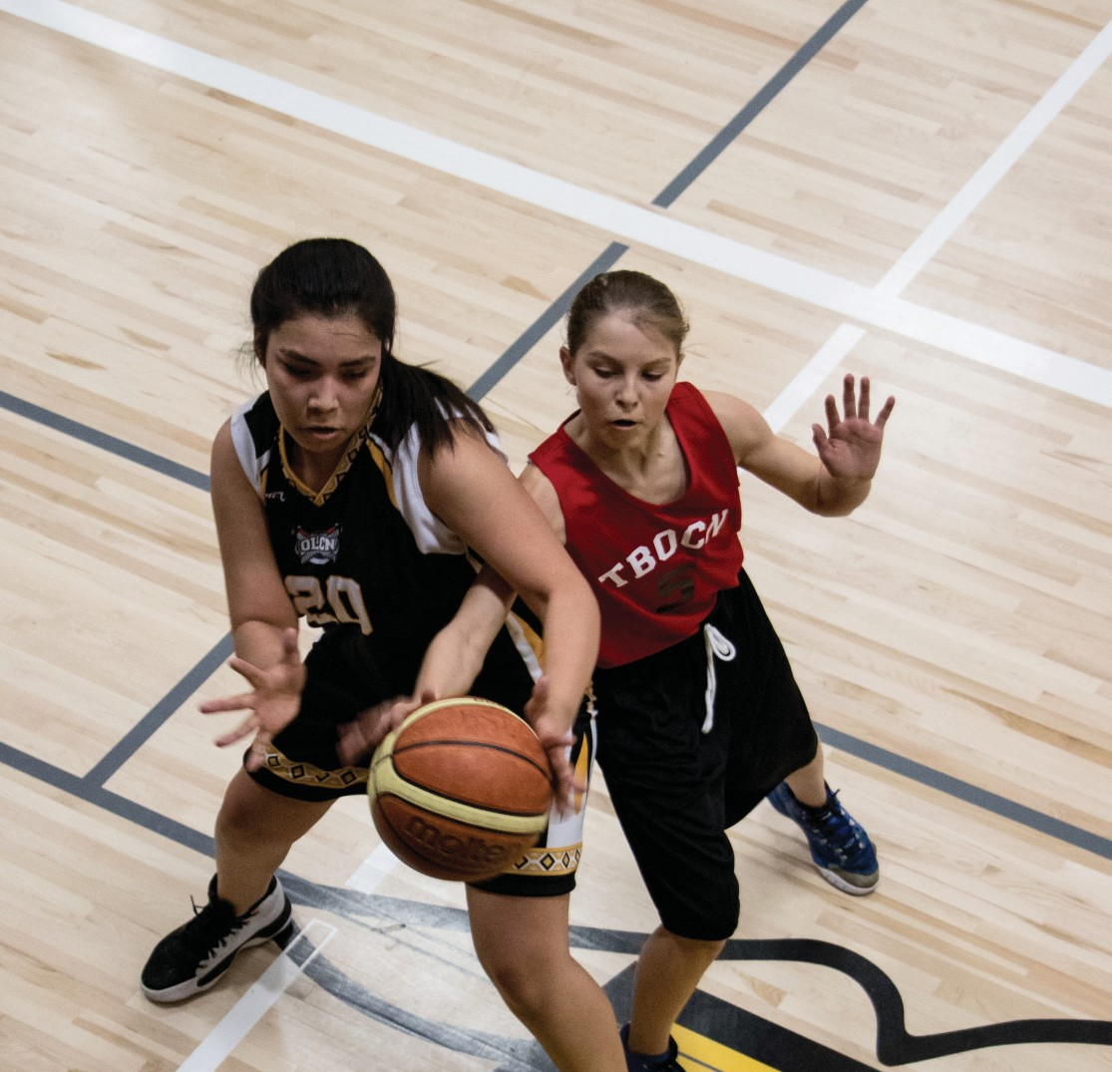


INDIGENOUS COMMUNITY SPORT DEVELOPMENT
GRANT PROGRAM
FOLLOW-UP FORM 2026

INDIGENOUS COMMUNITY SPORT DEVELOPMENT
GRANT PROGRAM FOLLOW-UP FORM

CONTACT INFORMATION |  |  |  |  |  | Date:
Name of Community/Organization:
Contact Person: |  |  |  |  |  | Title:
Address: |  |  |  |  |  |  |  | Postal Code:
Phone: |  |  |  | Email
Alternate Contact: |  |  |  |  |  | Title:
Address: |  |  |  |  |  |  |  | Postal Code:
Phone: |  |  |  | Email:
Finance: |  |  |  | Email:

EVALUATING, CELEBRATING AND SUSTAINING YOUR SPORT PROGRAM
PROGRAM INFORMATION Note: Most of the information can be found in the application that was submitted previously.

Sport Program: |  |  |  | Amount Granted:
Summary of how the program ran:
Start Date: |  |  | End Date:

PARTICIPANT INFORMATION

Number of athletes that participated by age and gender group: (please fill in table below)
Age Range | Female | Male | TOTAL
 |  |  | 0
 |  |  | 0
What was the final percentage of Indigenous participants? |  |  | %
Are the program participant’s members of a Provincial Sport Organization? |  |  |  Yes  No
If no, please explain:

Number of coaches: |  | Were the coaches trained through ICOP? |  |  Yes  No
Please list name(s) of coaches:  (If additional space is required, please submit on separate sheet) |  |  | CC#  (If available)
1.
2.
3.
4.
5.
6.
Number of officials: |  | Were the officials trained through ICOP? |  | Yes  No
Please list name(s) of officials: (If additional space is required, please submit on separate sheet)
1.
2.
3.
4.
5.
6.
What partnerships were created through this program?
Did your program go as planned? Please explain:
Did the program meet the needs and benefits you wanted for the community’s children and youth?

Describe the program successes.
Describe the challenges you encountered.
Remember, challenges can help us discover a new way to do things and improve our programs.

Will you be running the program next year? |  Yes  No
Will you require funding for next year? |  Yes  No
What changes would you suggest improve/enhancing your sport program next year?

BUDGET SUMMARY
Note: You must show total expenses and revenue for the project. Revenue and expenses should be equal if possible. Copies of the actual receipts or an audited financial statement must be included.

INCOME | Budgeted Amount | Follow-up Actual
Indigenous Community Sport Development Grant | $ | $
Fundraising | $ | $
In-kind contributions (non-cash – please list)
1. | $ | $
2. | $ | $
3. | $ | $
Other sources (please list)
1. | $ | $
2. | $ | $
3. | $ | $
TOTAL INCOME | $ 0.00 | $ 0.00
EXPENDITURES: (identify in-kind expenditures with an asterisk*) | Amount | Follow-up Actual
Facilities (gym/arena usage) | $ | $
Equipment Costs | $ | $
Travel costs (fuel costs) | $ | $
Athlete Training/Development Costs | $ | $
Food/Nutrition: (max 10%) | $ | $
Registration Fees | $ | $
Other direct related expenditures (please list)
1. | $ | $
2. | $ | $
3. | $ | $
TOTAL EXPENDITURES | $ 0.00 | $ 0.00
Surplus/deficit without Indigenous Community Sport Grant funding | $ 0.00 | $ 0.00
Requested Grant Amount | $ | $

INFORMATION CERTIFICATION
I hereby certify that the information contained in this follow-up is accurate and complete.

Authorized Signature of Community Applicant Position

Print Name Date

PLEASE SEND COMPLETED FOLLOW-UP FORM TO:
Indigenous Community Sport Development Grant Program
Rivers West District for Sport, Culture & Recreation Inc.
Box 607, Kerrobert, SK S0L 1R0
ATTN: Bobbi Hebron, Community Development Coordinator
PH: 306-494-7771 EMAIL: cdcrosetown@riverswestdistrict.ca

CHECKLIST

Completed Follow-up Form

Completed budget summary in detail with copies of receipts or audited financial statement Success Stories, Photos/Photo releases




