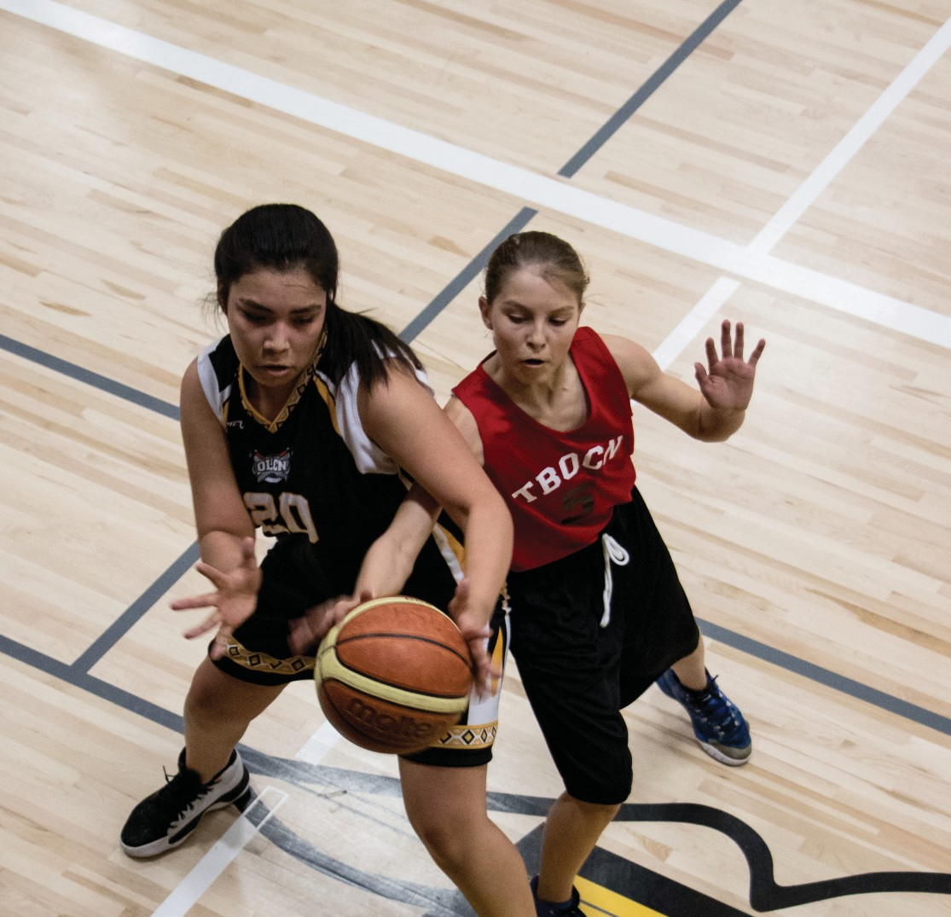


INDIGENOUS COMMUNITY SPORT DEVELOPMENT
GRANT PROGRAM
APPLICATION FORM 2026

INDIGENOUS COMMUNITY SPORT DEVELOPMENT
GRANT PROGRAM APPLICATION FORM

CONTACT INFORMATION |  |  |  |  | Date:
Name of Community/Organization:
Cheque Payable to: (if different from above)
Contact Person: |  |  |  |  | Position
Address: |  |  |  |  |  | Postal Code:
Phone: |  |  | Email:
Alternate Contact: |  |  |  |  | Position
Address: |  |  |  |  |  | Postal Code:
Phone: |  |  | Email:
Administrative Contact: (Ex. Finance)
Email:

LETTER OF SUPPORT (A letter of support must be included with application)
From: |  | Contact:

PROGRAM INFORMATION

Sport Program: |  |  |  | Amount Requested:
Brief Summary of sport program:
Start Date: |  |  | End Date:

DESIGNING YOUR SPORT PROGRAM
(Step 2 in the Community Sport for Children and Youth Planning Toolkit - please refer to the toolkit for TIPS and available resources to complete the application)

SUPPORT NEEDED
Is the sport program new or existing? (please check)
 New sport program OR  Existing sport which will be further developed.

Future Goals of your sport: (sustaining sport development)
What partners have you identified to support the sport program? Inside community / outside community (Provincial Sport Organization, Tribal Council, School Division, Community)

PARTICIPANTS

Using the data from the answers in Step 1, please check who the sport program going to support:
 Both males and females  Males  Females
What age(s) are the participants? |  | How many participants will be involved?
How will your program recruit participants? (Please describe below)
DEVELOPMENTALLY APPROPRIATE SPORT
What do you need to do in order to deliver the program? (Trained coaches, league play, skills camps)
SPORTS TIMELINE
LEAGUES AND COMPETITIONS (COVID-19 restrictions apply)

Will the sport program be part of a league, if so which one?
Will the team participate in competitions/league, if so, how many, and where? (Please list)
Competition/League | Date | Location

FACILITY
Where will the team practice? (Please list below) |  | Is the facility free?
 |  |  Yes  No
COACHES
Do you need coaches? |  Yes No
Will you require a coaching clinic? | Yes No
OFFICIALS
Do you need officials? | Yes  No
Will you require official’s clinic? | Yes No
VOLUNTEERS
How many volunteers will you need to help out with the program & how will volunteers be recruited?

DELIVERING YOUR SPORT PROGRAM
(Step 3 in the Community Sport for Children and Youth Planning Toolkit - please refer to the toolkit for TIPS and available resources to complete the application)

SUPPORT NEEDED
In the previous step you were able to identify who can help you with your sport program, please list who will support you to deliver your sport program: (only answer what applies)
Coach -
Manager -
Main Official -
Transportation Driver -
Community Leader (Principal, Councilor) -
Helper/Volunteer -
Helper/Volunteer -
Other -
FUNDING ACKNOWLEDGEMENT
How will you promote this program and publicly acknowledge Sask Lotteries as the source of funding for your program? (please check below)
Posters Newsletter Social Media (Facebook) Radio Annual Report TV Speeches Word of mouth Other:

BUDGET SUMMARY
activities
Note: This budget summary will be the same used for the follow-up submission.

INCOME | Budgeted Amount | Follow-up Actual
Indigenous Community Sport Development Grant | $ | $
Fundraising | $ | $
Other sources (please list)
1. | $ | $
2. | $ | $
TOTAL INCOME | $ 0.00 | $ 0.00
EXPENDITURES: (identify in-kind expenditures with an asterisk*) | Amount | Follow-up Actual
Facilities (gym/arena usage) | $ | $
Equipment Costs: Please list main items needed:
a) | $ | $
b) | $ | $
c) | $ | $
Travel costs (fuel costs, rentals, charter service) | $ | $
Athlete Training / Development Cost | $ | $
Food/Nutrition: (max 10%) | $ | $
Registration Fees | $ | $
Other direct related expenditures (please list)
1. | $ | $
2. | $ | $
TOTAL EXPENDITURES | $ 0.00 | $ 0.00
Surplus/deficit without Indigenous Community Sport Grant funding | $ 0.00 | $ 0.00
Requested Grant Amount | $ | $

INFORMATION CERTIFICATION
I hereby certify that the information contained in this application is accurate and complete. Which include a completed application form, a letter of support from the community and a completed budget summary in detail.

Authorized Signature of Community Applicant Position

CHECKLIST

Completed Application Form
Two letters of support from community leaders
(Ex. school administrator, town administrator, minor sport organization president, recreation board chair, or community elected official (Chief or Mayor))
Completed budget summary in detail

PLEASE SEND COMPLETED APPLICATION TO:
Indigenous Community Sport Development Grant Program
Rivers West District for Sport, Culture & Recreation Box 607, Kerrobert, SK. S0L 1R0
ATTN: Bobbi Hebron, Community Development Coordinator
PH: 306-494-7771 EMAIL: cdcrosetown@riverswestdistrict.ca


